3D Visualization of Potential Energy Field

Project One Proposal

Computer Simulation

Ziyi Zhang

Dear Professor Peskin,

I am writing this letter to demonstrate my project plan in your course Computer Simulation. The project will visualize the potential energy field of a planar spring-mass system with a 3D surface, and use this surface to help understand certain behaviors of the dynamics system.

The project is consisted of the following two parts:

* For any point in the spring mass system, we can place an imaginary probe to calculate the force the system exerts on it. There always exists a slope at that point that can provide the same force, both in magnitude and direction. The combination of these two ideas enables us to reconstruct a surface visualizing the potential energy field (see supplementary material for details).
* This visualization surface makes it clear how masses are affecting each other and how the overall potential energy field looks like. The second part will focus on using different setups to explore the underlying link between a potential field and its dynamics.

This visualization surface has quite a few constraints and is time-consuming. But I have implemented a primitive version and is now confident that it will work. It is high time I wrote a better software using the knowledge learnt in this semester.

Yours sincerely,

Ziyi Zhang

Supplementary Material

Mathematically this project is feasible, but there is no guarantee. So I have implemented a prototype to see how it looks like, and here is the result:

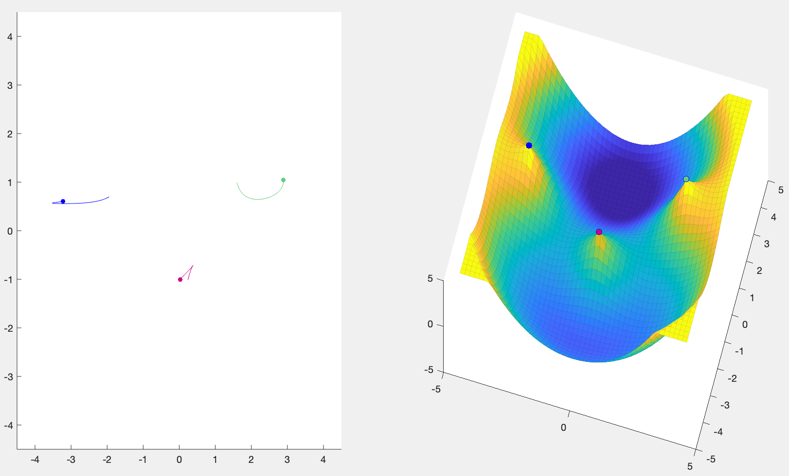

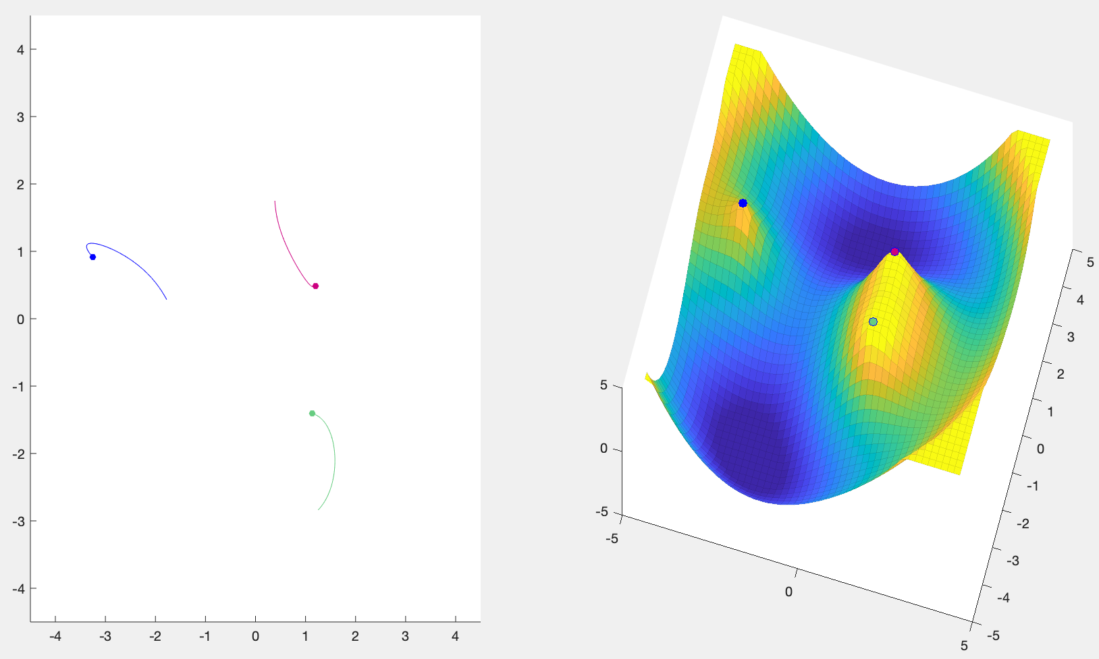

LHS is the simulation of a three-body spring model with trajectory. RHS is the reconstructed potential field surface. The way to interpret it is that if we put an imaginary ball in both sides: in the LHS the ball is connected by springs with all three bodies, and in the RHS there is no spring and the ball moves freely because of gravity. The surface is reconstructed so that the trajectories of the ball will be exactly the same.

I have found many downsides of such visualization using this prototype program. For example, the inverse gradient calculation is so slow that it is hard to make it in real-time. There are many other mathematical cruxes to be solved. But in general I think it is promising and I will see what I can do with this.